**Individual Tasks-1,2 & 6**

**CN4005-mental Wealth**

**By-**

**Md Towhedur Rahman**

**Table of Contents:**

**Task-1…………………………………………………………………………………………………………………………………2**

Self-Evaluation…………………………………………………………………………………………………………….2-8

Email Evidence of the Mental Wealth Form…………………………………………………………………….9

Initial CV……………………………………………………………………………………………………………………………9

**Task-2……………………………………………………………………………………………………………………………10**

Individual Time Management Plan……………………………………………………………………………………10

**Task-6………………………………………………………………………………………………………………………….11**

Final Self Evaluation Form………………………………………………………………………………………11-17

Updated CV……………………………………………………………………………………………………………………….18

**Task-1**

**Self-Assessment Form:**

| **Area** | **Skill level (1-5)**  **0 -2 = No evidence**  **2 - 3 = limited evidence**  **3 - 6 = Some evidence**  **7- 9 = strong evidence**  **10 = outstanding – I am better than the teachers!** | **Evidence** | | **Plans to improve** |
| --- | --- | --- | --- | --- |
| **Domain A: Knowledge and intellectual abilities:**  Relates to the knowledge & intellectual abilities needed to be able to carry out excellent research. | | | | |
| **Knowledge base** |  |  | |  |
| 1 Programming knowledge (Java) | **4** | I passed the module with 76% marks, and I did not fail any of the TCAs. But I am not fully confident. | | *I did some review study during the holiday. I will spend more time to have a clear understanding and be confident before the second year.* |
| 2. Web Design Skills (HTML/CSS) | **3** | I have completed level three but have not done anything on CSS. | | *I will commit to attending all the lectures and practical. I will read the lecture in advance and try the practice at home first.* |
| 3. Database Design skills (E-R) | **3** | I have completed level three, but I did not understand it very well. In last semester it developed a bit. Still, I am not fully confident on it. I have a negative thinking that it bis very hard. | | *I need guidance how to take-off the negativity from my mind and the way to understand easily. I have plan to put extra effort for it this summer. I will contact to my academic advisor to get right direction; I will also ask help from my friends who has good knowledge on it.* |
| 4. Maths for computing. | **5** | In the first semester, everything was new to me, and I got 55% on the module. I was not able to focus on the beginning of the module. I love math and enjoy it. | | *I am not scared of it.* I love math and enjoy it. *Will continue my approach to studying math.* |
| 5. Research skills (finding information) | **5** | I have developed some research skills in level three by doing assignments. I gain some knowledge when I was writing a research proposal after my MA. | | I am good at reading I can decide what to read based on the research topic. Reading is one of the most important skills to find information. I will put myself during the semester to develop more of the skill. |
| 6. Research citation and referencing skills. | **3** | I have done research in level three, and I have a good understanding of reference but not much about citation, I have only Harvard referencing for my assignment. | | *I need to focus on citation during this semester. I have registered for English and Academic writing in Moodle, I need to read and watch the materials to develop the skill.* |
| 7. Computer networking skills. | **3** | I have studied Application of networks, LAN, WAN and Network Topologies in level three. | | *I found some mathematical terms in here in my module and I believe I will develop my networking skills by following lectures and completing every week task on time.* |
| **Cognitive abilities** |  |  | |  |
| 1. Analysis skills | **3** | As analytical skills are soft and critical skills. Some analytical skills include very critical thinking, and I am not very fast at it. | | I need to be more aware and find opportunities to develop my analytical ability during my study at UEL. |
| 2. Paraphrasing skills. | **3** | I can create a restatement of the meaning of a text or passage using my own words | |  |
| 3. Critical thinking skills. | **3** | **I take time in critical thinking.** | | **I am keen to develop the ability to critical thinking.** |
| 4. evaluation skills | **4** | **I can evaluate the impact and outcomes of my own research activities** | | **I need to develop more of these skills during my study.** |
| 5. Solving problems | **5** |  | |  |
| **Creativity** |  |  | |  |
| 1. Innovative idea | **3** |  | | **Here is the opportunity in this module to explore my innovative idea or thinking by doing practical’s at UEL. I am ready to take this opportunity by engaging in it.** |
| 1. Argument construction | **3** | **I have a weak argumental capacity. I need to build strong argumental ability.** | | **I can build up my argument construction ability by discussing with my classmates during lessons and lab sessions. I** |
| **Domain B: Personal effectiveness:**  The personal qualities, career & self-management skills required to take ownership of & engage in professional development. | | | | |
| **Personal Qualities** |  |  | |  |
| 1. Enthusiasm | **4** | **I have the enthusiasm and can maintain strong enthusiasm for my own research** | | **I will try to be creative to be enthusiastic.** |
| 1. Perseverance | **7** | I can work towards a goal overcome obstacles and challenges to achieve the success, | | **I am willing to build more of this capacity.** |
| 1. Self-confidence | **7** | I have always had positive feelings and I accept my faults. | | **Weakness I have I am willing to strengthen it.** |
| 1. Self-reflection | **7** | I practice regularly to learn and develop from my mistakes. | | **I want to keep it up to develop my weak areas.** |
| 1. Responsibility | **7** | I am capable of eventually taking responsibility for my own project. | | **I want to learn more about responsibility.** |
| **Self-management** |  |  | |  |
| 1. Preparation & prioritization | **5** | I plan and prepare my work in order to achieve my goal. | | **I will learn more about it in this module.** |
| 1. Commitment to study | **5** | I always try to fulfill my commitment. | | **I am determined to study more.** |
| 1. Time management | **6** | I am good at time management. | | **I will prove this by doing all my assignments on time.** |
| 1. Responsiveness to change | **5** | I can change my strategy when it is necessary. | | **I believe I will make a strong capacity of it during my study at UEL.** |
| 1. Work-life balance | ***6*** | *I can prioritize to balance work and life.* | | *Still, I need to learn more to develop an awareness of it.* |
| **Professional & career development** |  |  | |  |
| 1. Career management | **6** | I can effectively promote my personal skills, characteristics, and experience in CVs, applications, and interviews. | | Need to progress to fulfill my goals. |
| 1. Continuing professional development | **5** | I am able to develop and maintain my own records of achievements and experience. | | Always willing to learn new things |
| 1. Responsiveness to opportunities | **6** | I seek to gain broader experience | | Always willing to learn new things |
| 1. Networking | **5** | I can build and maintain working connections with co-workers, and supervisors within the institution. | | I will build up this capacity during my study at UEL. |
| **Domain C: Engagement, influence & impact :**  The knowledge, understanding & skills needed to engage with, influence & impact on the academic, social, cultural, economic & broader context. | | | | |
| **Working with others** |  |  |  | |
| 1. Collegiality | **6** | I am considerate to others at my work. | Need to develop | |
| 1. Team working | **7** | I always appreciate others’ contributions. | Need to develop | |
| 1. People management | **5** |  |  | |
| 1. Influence & leadership | **6** | I need to gain more of it. | I need to gain more of it. | |
| 1. Collaboration | **5** |  |  | |
| 1. Equality & diversity | **5** | I respect full of individuals. |  | |
| 1. Communication methods | **5** | I exchange knowledge with classmates and colleagues. | I have to be more open and wider to gain it, | |
| **Domain D : Business**  The knowledge and understanding of business and what this means for you as a potential employee. | | | | |
| 1. Understanding business | **4** | Some specific business |  | |
| 1. Understanding employers | **5** | I need to have more understanding | Need to develop. | |
| Total Score: | **179** |  |  | |

**Email Evidence of the Mental Wealth Form:**

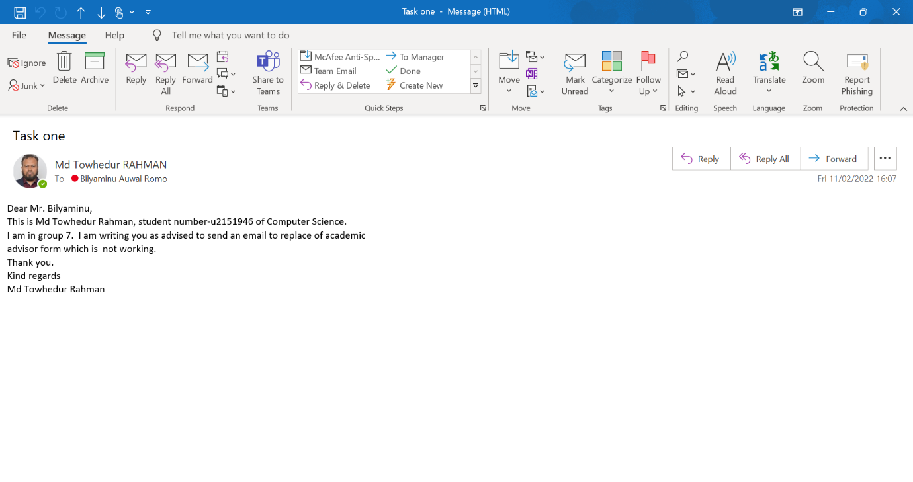

**Initial CV:**

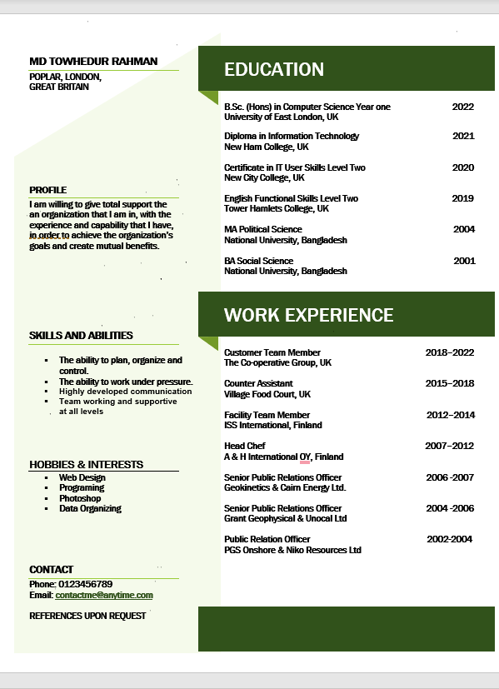

**Task-2:**

**Individual Time Management Plan:**

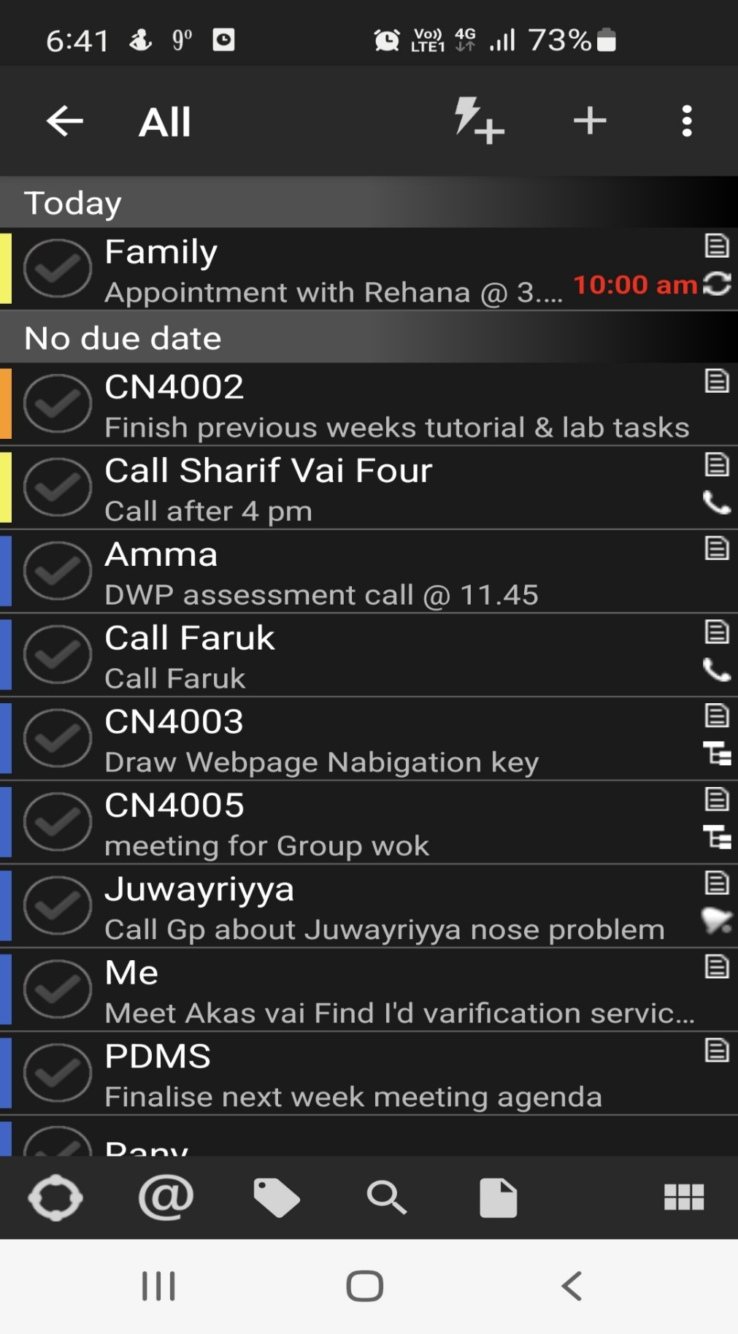

**Task-6:**

**Final Self-Evaluation Form:**

| **Area** | **Skill level (1-5)**  **0 -2 = No evidence**  **2 - 3 = limited evidence**  **3 - 6 = Some evidence**  **7- 9 = strong evidence**  **10 = outstanding – I am better than the teachers!** | **Evidence** | | **Plans to improve** |
| --- | --- | --- | --- | --- |
| **Domain A: Knowledge and intellectual abilities:**  Relates to the knowledge & intellectual abilities needed to be able to carry out excellent research. | | | | |
| **Knowledge base** |  |  | |  |
| 1 Programming knowledge (Java) | **5** | I had some C++ knowledge from level three and this year’s experience increased my knowledge more. | | I will use my summer holiday learning to improve my knowledge. |
| 2. Web Design Skills (HTML/CSS) | **4** | As I mention, I have limited knowledge of web design previously. | | I will make myself ready before the second year for the advanced level. I will use my summertime to learn more. |
| 3. Database Design skills (E-R) | **4** | After level four a good amount of confidence has grown. | | *I will dedicate myself to learning it perfectly to overcome my negativity.* |
| 4. Maths for computing. | **6** | The new things I have learned were interesting to me. | | I Will continue my approach to studying math more and more. |
| 5. Research skills (finding information) | **5** | I have developed some research skills in level three by doing assignments. I gain some knowledge when I was writing a research proposal after my MA. | | I will learn how to use more relevant sources and make a firm conclusion. |
| 6. Research citation and referencing skills. | **5** | I have done research in level three, and I have a good understanding of reference but not much about citation, I have only Harvard referencing for my assignment. | | I will follow the instruction of the catch-up session and go on YouTube and watch the video to give me additional support. |
| 7. Computer networking skills. | **5** | have studied the Application of networks, LAN, WAN, and Network Topologies in level three. | | I can improve my networking skills by sharing initial ideas with others and already planning with my groupmate. |
| **Cognitive abilities** |  |  | |  |
| 1. Analysis skills | **6** | As analytical skills are soft and critical skills. Some analytical skills include very critical thinking, and I am not very fast at it. | | I will continue to improve and search for YouTube videos to consolidate my understanding |
| 2. Paraphrasing skills. | **6** | I have learned a lot from my last projects. | | I can improve my paraphrasing skills by reading IT-related articles to help me get a better understanding of what to say when paraphrasing or watch YouTube videos for further support. |
| 3. Critical thinking skills. | **6** | During my mental wealth innovative idea thinking with my group, I Geared up my thinking and it help me a lot. | | To help me improve my critical thinking skills, I can use online courses to support me further. |
| 4. evaluation skills | **7** | During the year of my study this year, I was able to summarise and reflect on my projects on cn4000 and cn4005. | | To improve my evaluation skills, I will be more careful and assess my quality of work in the coming project. |
| 5. Solving problems | **6** | The method and technique of learning through the year help to solve problems very easily. | | I can improve my problem-solving skills by sharing ideas with other students to get a better understanding. |
| **Creativity** |  |  | |  |
| 1. Innovative ideas | **6** | I gain knowledge during my Cn4005 module assignment. | | I can develop this skill during the summer holiday by doing more research and sharing it with my classmates. |
| 1. Argument construction | **5** | During my mental wealth project with my group meeting and working, I developed it much better than previous. | | By can share ideas outside classes with fellow students to get additional understanding. |
| **Domain B: Personal effectiveness:**  The personal qualities, career & self-management skills required to take ownership for & engage in professional development. | | | | |
| **Personal Qualities** |  |  | |  |
| 1. Enthusiasm | **6** | I have always been motivated and optimistic about learning new things. This year my fairness in doing something ease a lot. | | I can ask questions about a specific topic that I am not sure about with students and my tutor. |
| 1. Perseverance | **6** | I always remember that perseverance is the key to success and go ahead with this motivation. | | Stick to a good time schedule every week to help me better organize important tasks. |
| 1. Self-confidence | **7** | I knew my weakness and strength before the year and tried to overcome them by asking for help from my classmates and teachers. | | I will improve my confidence by asking questions to fellow students and my tutors. |
| 1. Self-reflection | **7** | I am always ready to learn, and it helps me a lot. | | I will improve my self-reflection by adapting my techniques of learning. |
| 1. Responsibility | **6** | I was the group leader during the course of my project and managed successfully. | | I will improve my responsibility by having the right intention on what to finish off. |
| **Self-management** |  | I managed to submit all my work without missing deadlines. | |  |
| 1. Preparation & prioritisation | **6** | I follow the lecturer and tutors’ guidelines and prepared myself for my study. | | I can improve this by focusing on areas that need improvement such as planning for important events. |
| 1. Commitment to study | **7** | I was committed to submitting my work within the deadline and was successful | | By studying in a quiet environment and avoiding unnecessary distractions. |
| 1. Time management | **6** | I divided my time between individual tasks and project work based on the deadline and it helps a lot. | | By having breaks between each task to prevent the feeling of being overwhelmed. |
| 1. Responsiveness to change | **7** | I ask for guidance when I needed. | | I can develop procedures that can help me determine what type of change is needed. |
| 1. Work-life balance | ***6*** | *I always balanced my family, work, and study life.* | | Making decisive plans for the long term. |
| **Professional & career development** |  |  | |  |
| 1. Career management | **5** | I am able to set goals for my career so that I can be successful. | | Listing weaknesses and improving on them for the long term. |
| 1. Continuing professional development | **5** | I dedicate my time to learning and success the aim. | | By managing distractions and continuing to meet the aim. |
| 1. Responsiveness to opportunities | **6** | I learn some lessons from different websites and apps to develop. | | By measuring my performance and making improvements to everyday tasks |
| 1. Networking | **5** | It has improved as I was able to manage and discuss with my peers which helps me lot. | | By improving my communication with others and sharing ideas |
| **Domain C: Engagement, influence & impact :**  The knowledge, understanding & skills needed to engage with, influence & impact on the academic, social, cultural, economic & broader context. | | | | |
| **Working with others** |  |  |  | |
| 1. Collegiality | **5** | I always value my team members’ opinions and it helps to finish work on time. | Help group members with their tasks if they get stuck. | |
| 1. Team working | **6** | I was so happy during my group work. | By contributing more time effectively with team members. | |
| 1. People management | **6** | I had work experience as a team leader, and I am engaged with other activities, it helps me a lot manage my teammates. | By focusing on communication skills in upcoming projects and studies. | |
| 1. Influence & leadership | **5** | The same experience I had and managed it properly during the year. | By improving decision-making to ensure the project finishes smoothly. | |
| 1. Collaboration | **7** | I am openhearted to work with group members. | By creating a supportive work environment for all members. | |
| 1. Equality & diversity | **7** | I treat as I expect others to treat me, people, with good manners and respect. | It will be great to treat people by Being aware of unconscious bias. | |
| 1. Communication methods | **7** | Regular communication helps us to complete our group work on time. | I will continue to study to improve it. | |
| **Domain D: Business**  The knowledge and understanding of business and what this means for you as a potential employee. | | | | |
| 1. Understanding business | **5** | I have some experience in different businesses. | I will develop it more by doing more research in summertime. | |
| 1. Understanding employers | **6** | I have a quite better understanding of employers. | I will develop it more by doing more research in summertime. | |
| Total Score: |  |  |  | |

**Updated CV:**

